Legaspi, DJ Paulo G. January 17, 2021

**CPE028-CPE412S2 Engr. Alonica R. Villanueva**

**Final Case Study**

**Topology:**

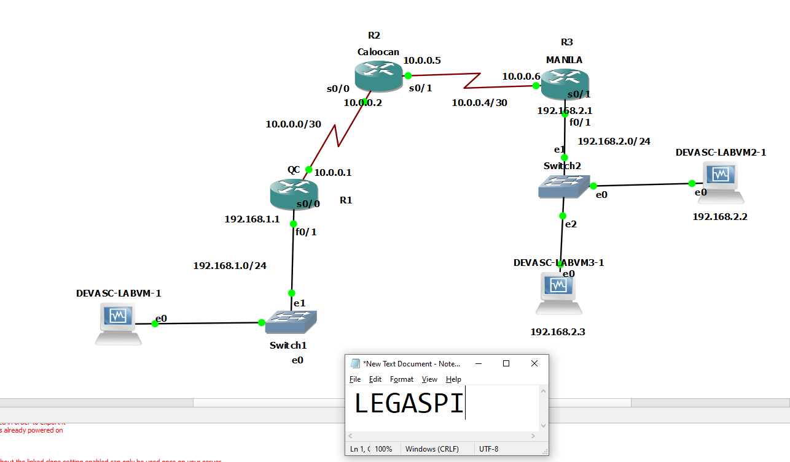

**Ip route and Interface Brief for the Routers**

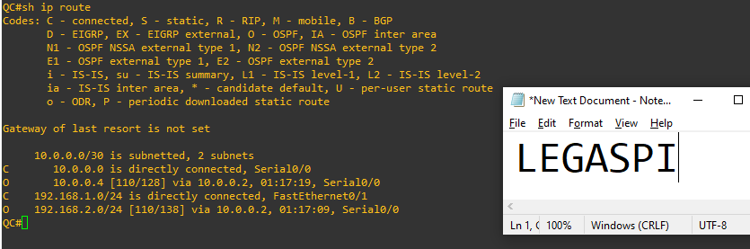

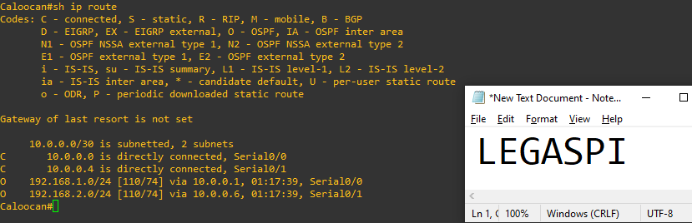

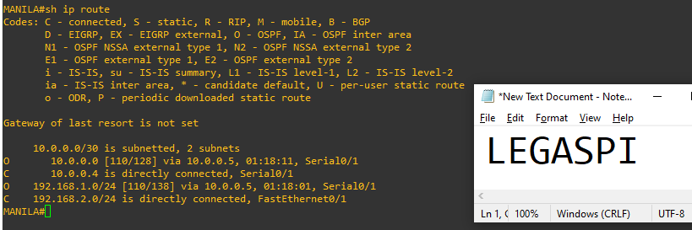

**Ansible Yaml Files:**

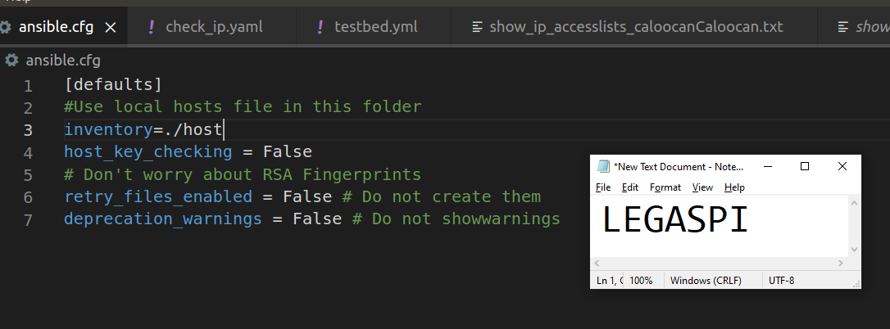

**Ansible.CFG**

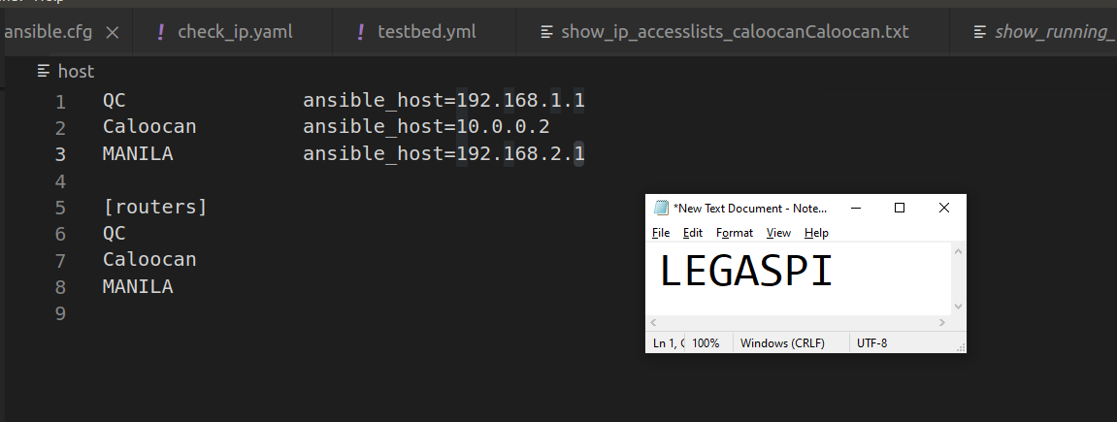

**Hosts**

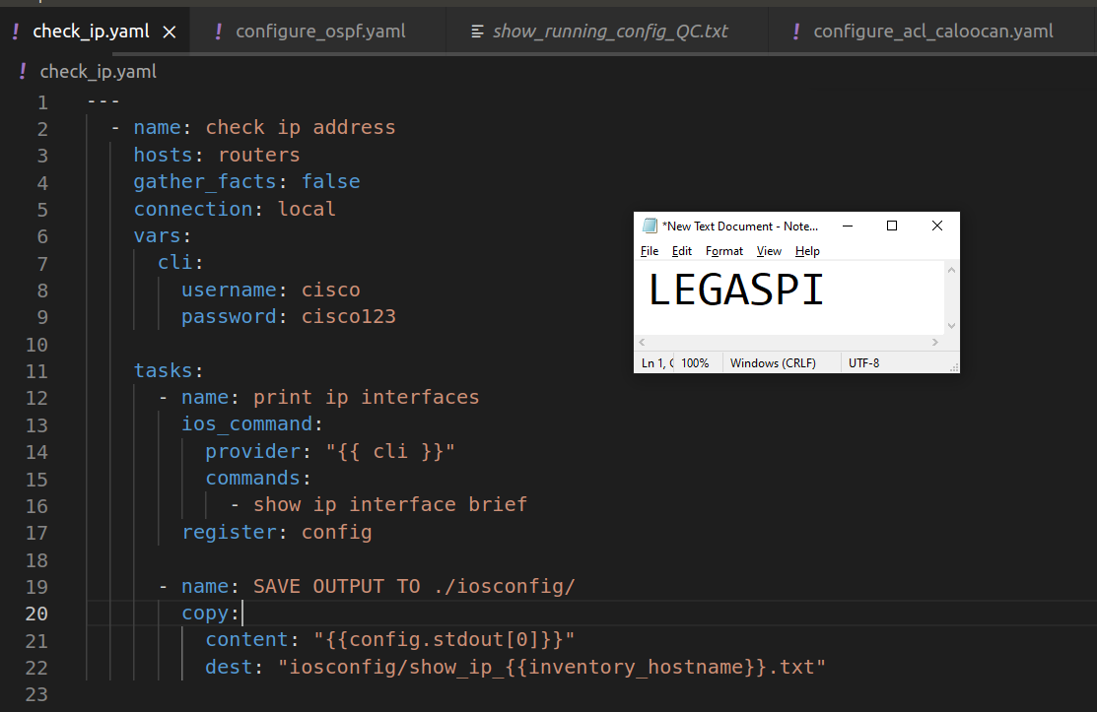

**CHECK IP YAML**

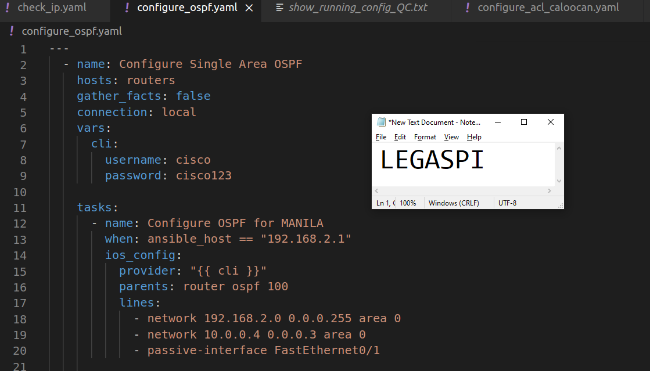

**CONFIGURE OSPF YAML**

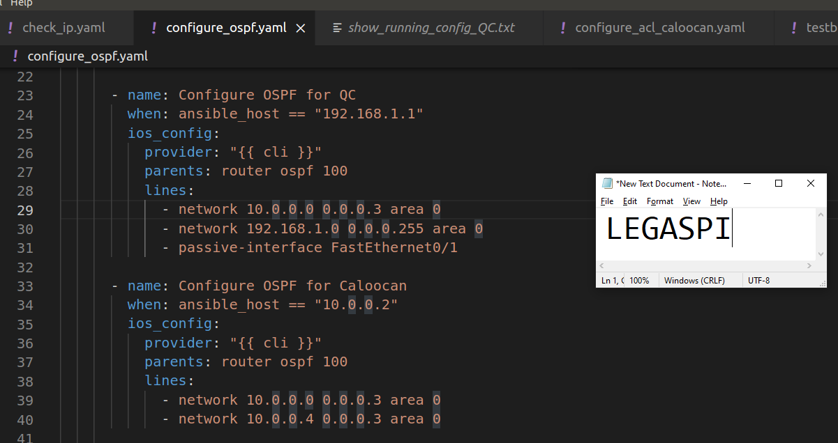

**CONFIGURE OSPF YAML**

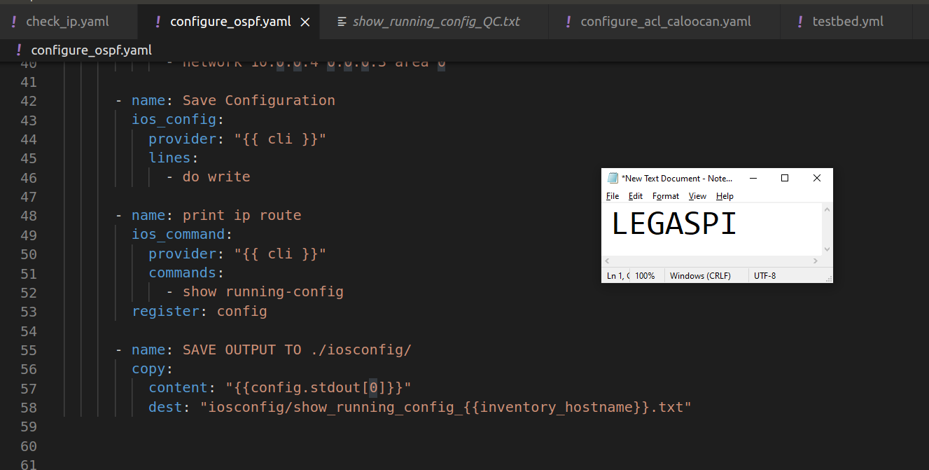

**CONFIGURE OSPF YAML**

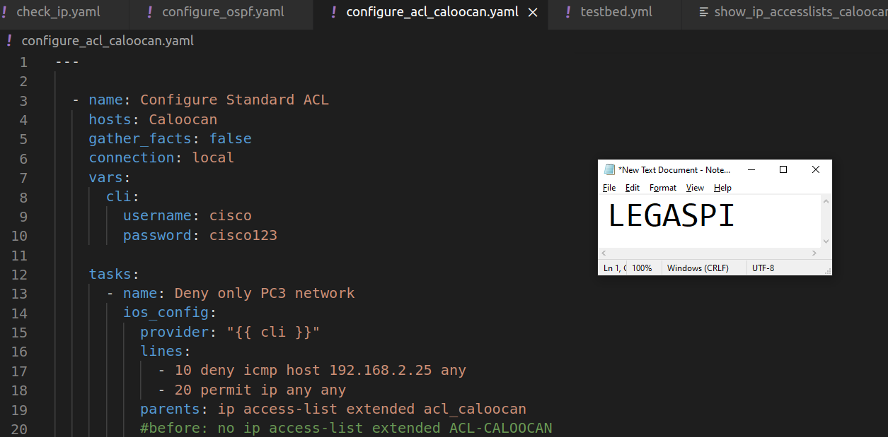

**CONFIGURE ACL CALOOCAN YAML**

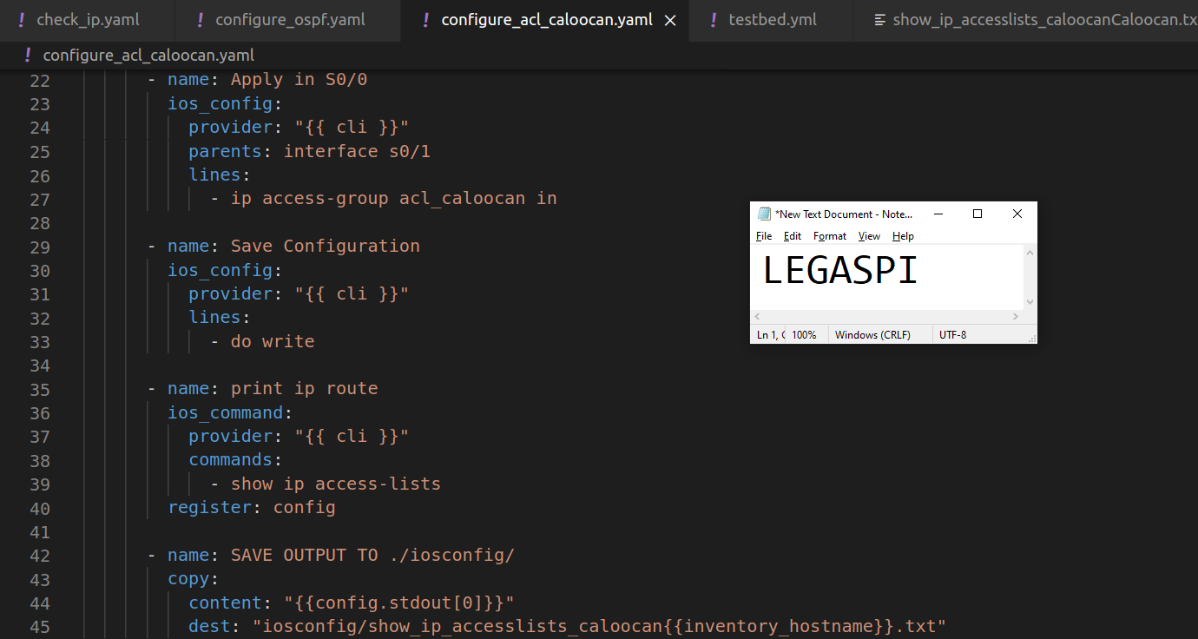

**CONFIGURE ACL CALOOCAN YAML**

**Running Ansible Yamls:**

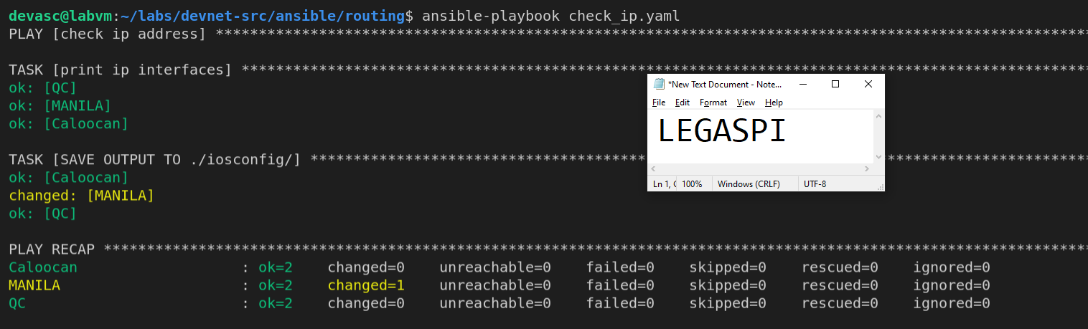

**Running CHECK_IP Yaml**

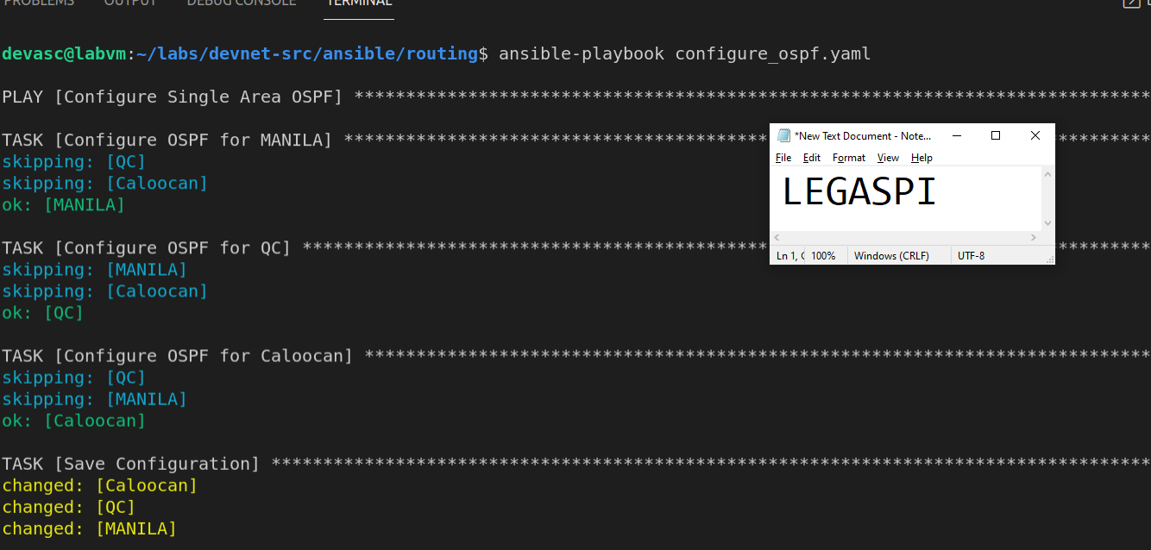

**Running CONFIGURE_OSPF Yaml**

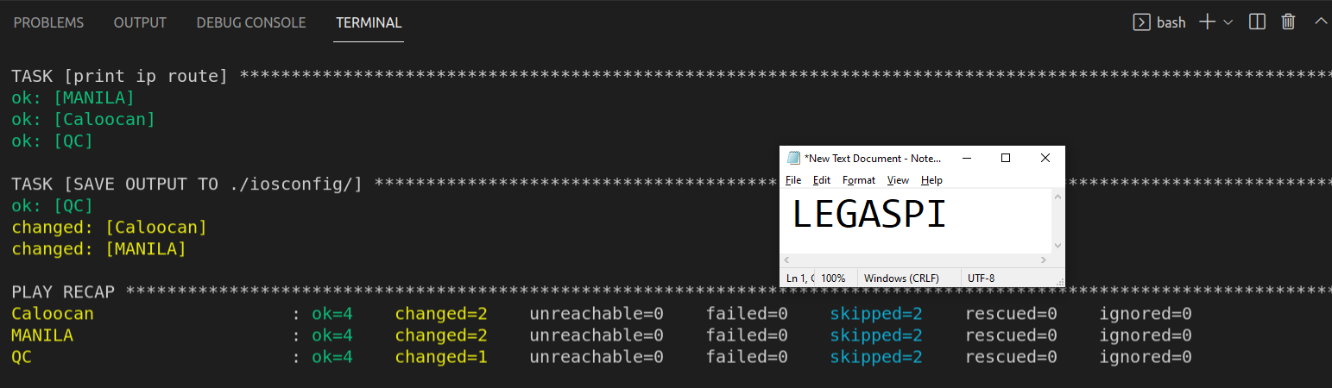

**Running CONFIGURE_OSPF Yaml**

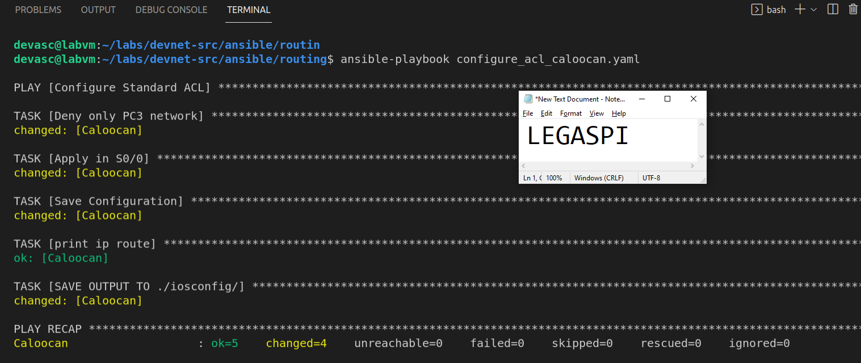

**Running CONFIGURE_ACL_CALOOCAN Yaml**

**Ios Config Folder Results**

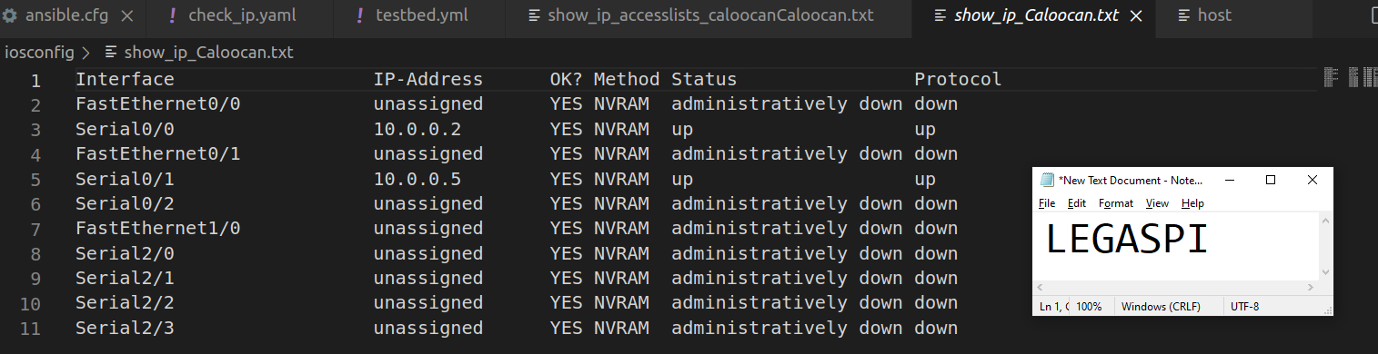

**SHOW IP CALOOCAN**

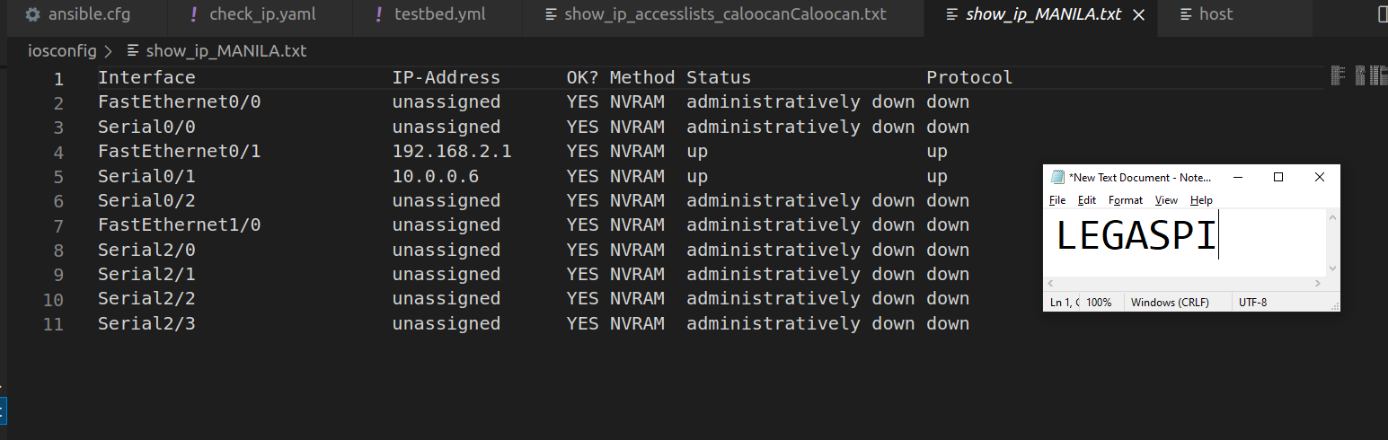

**SHOW IP MANILA**

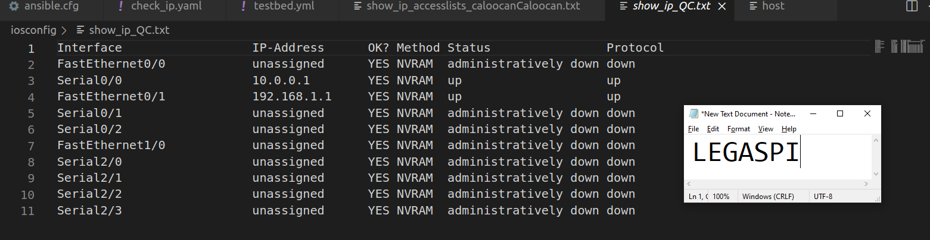 **SHOW IP QC**

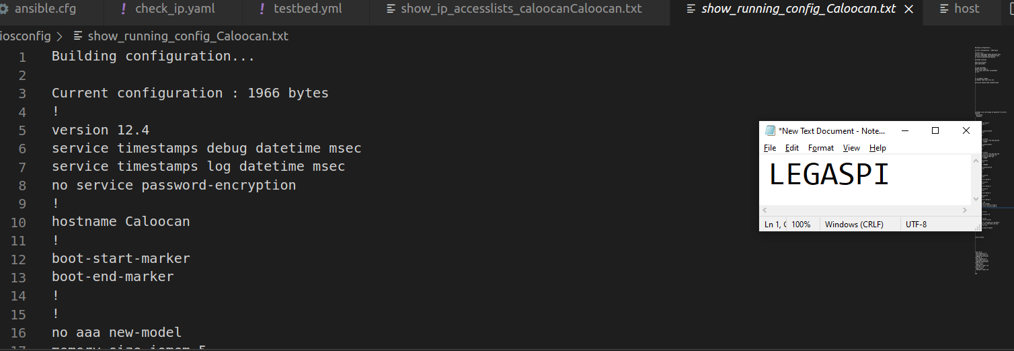

**Show Running Config Caloocan**

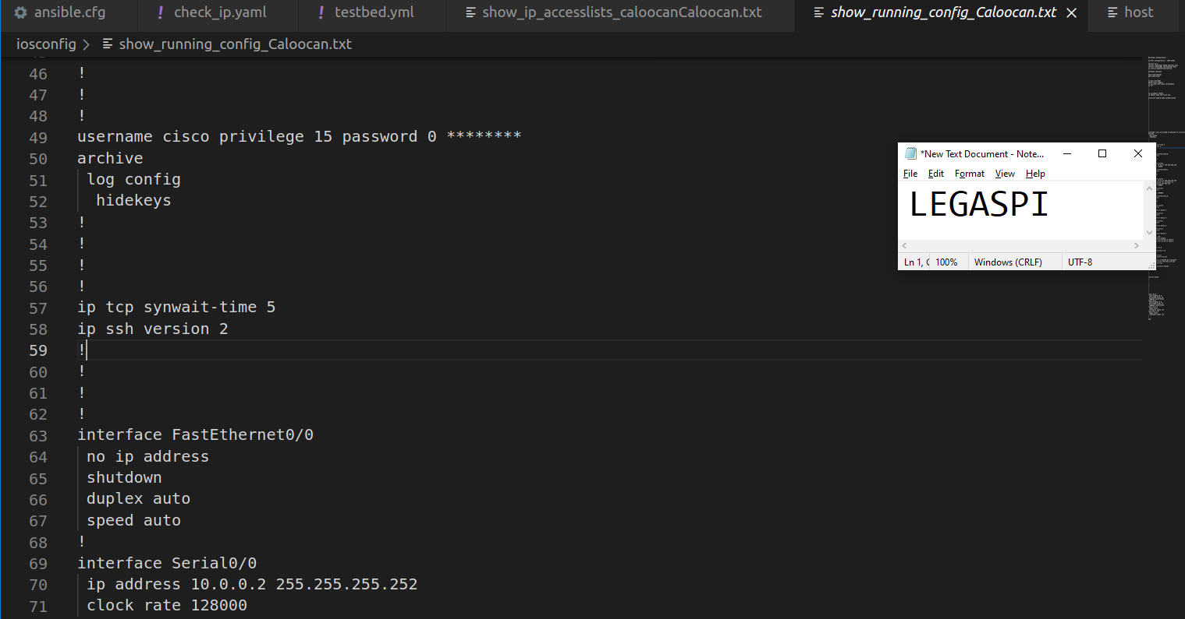

**Show Running Config Caloocan**

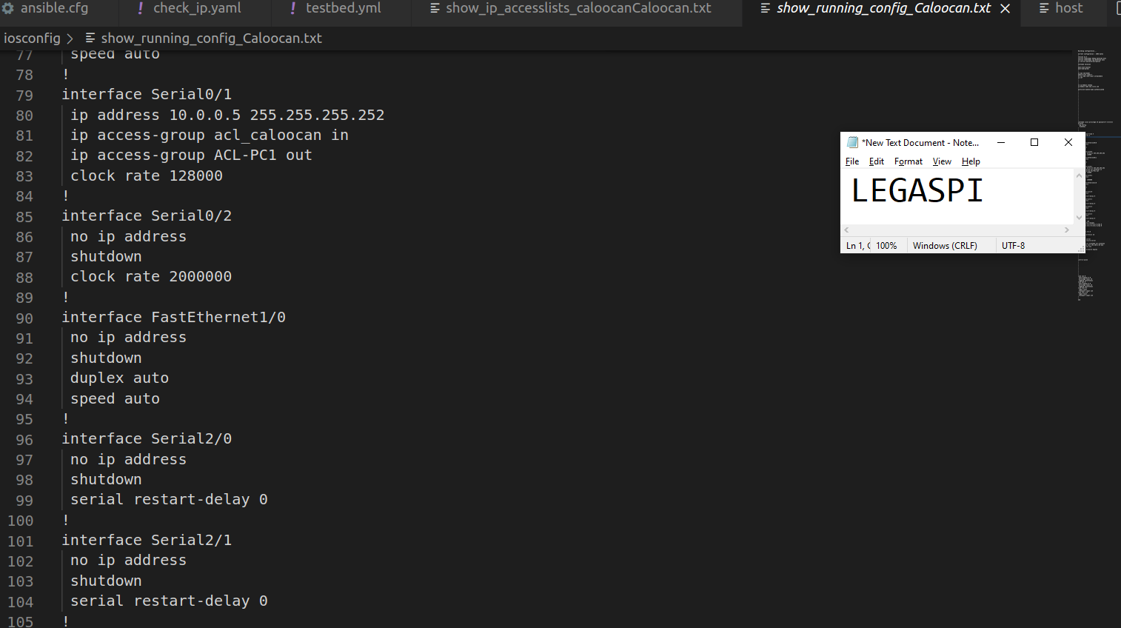

**Show Running Config Caloocan**

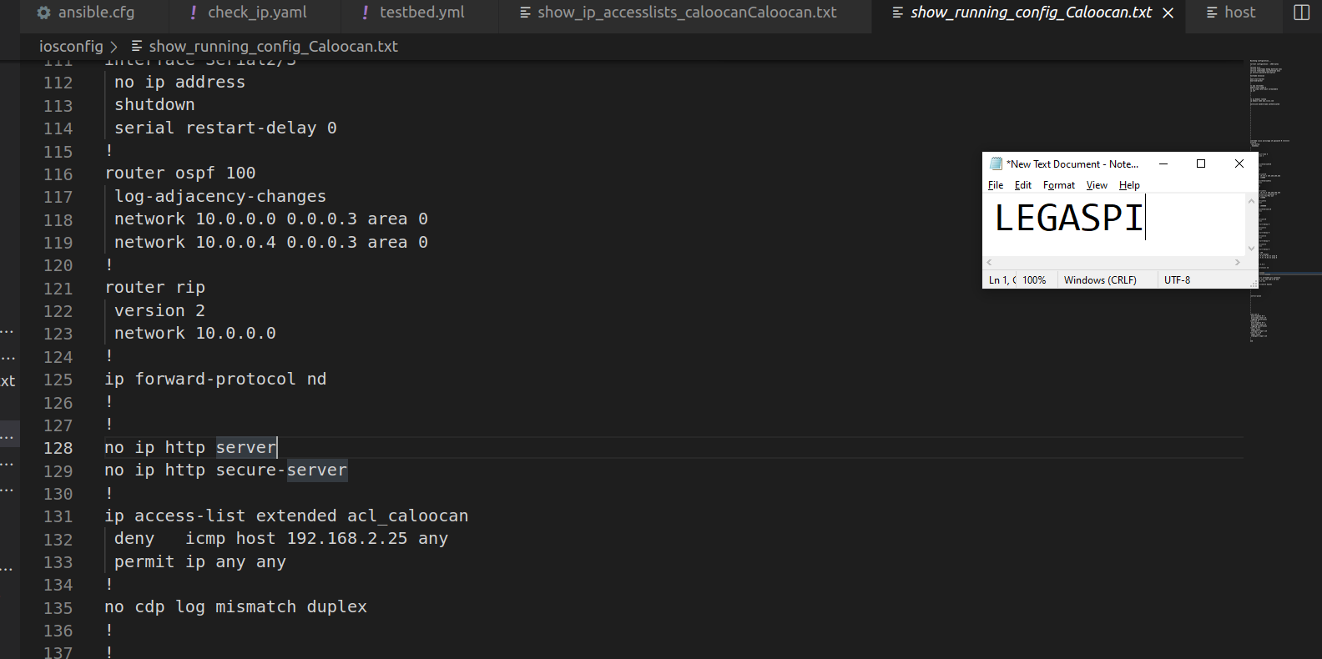

**Show Running Config Caloocan**

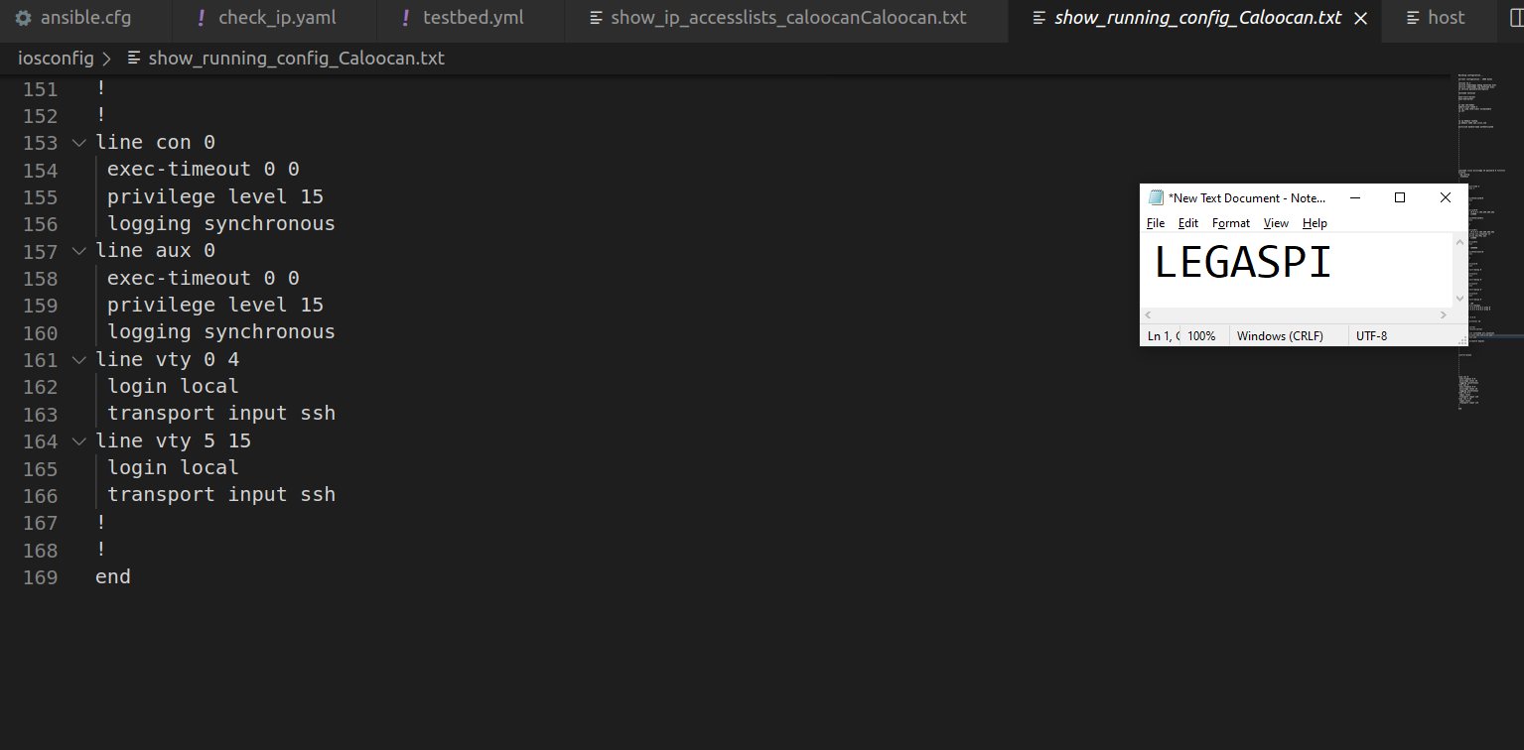

**Show Running Config Caloocan**

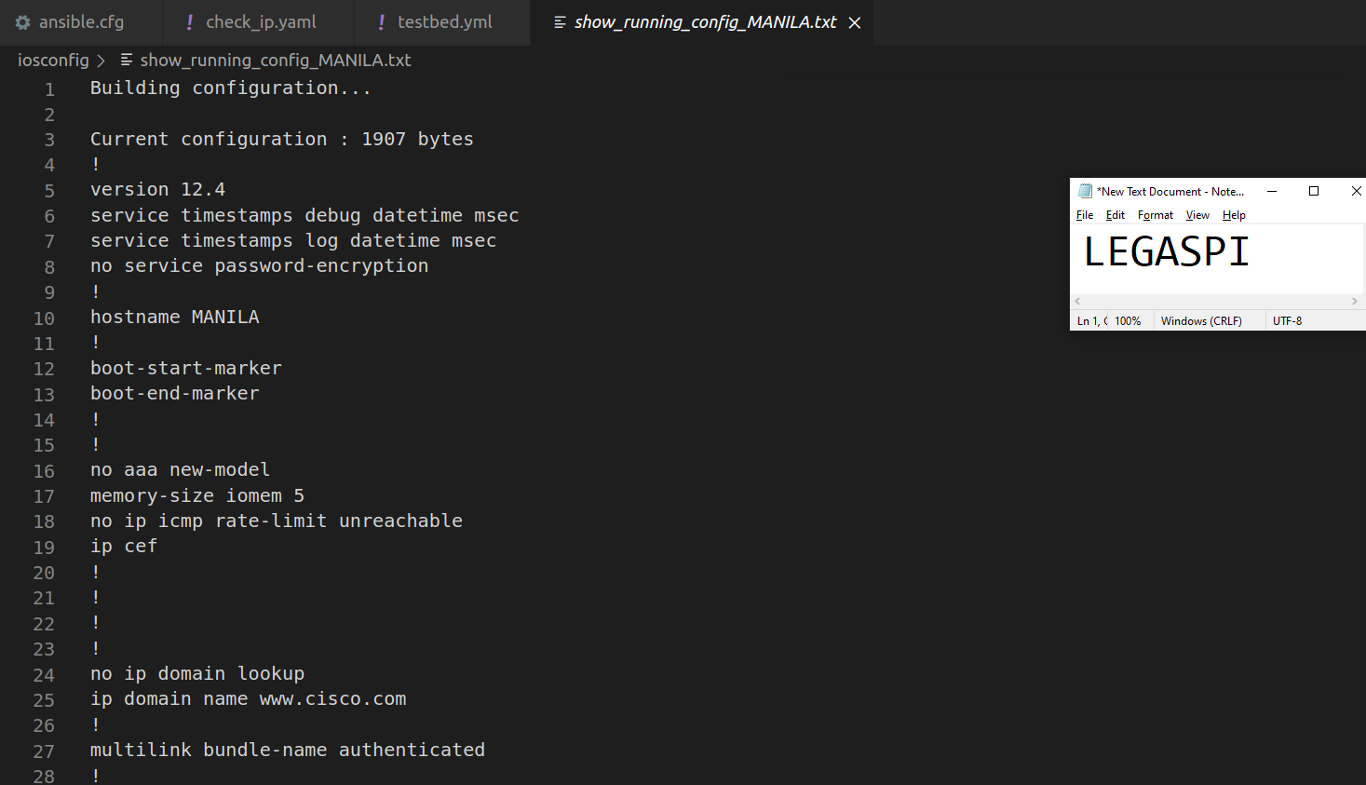

**Show Running Config MANILA**

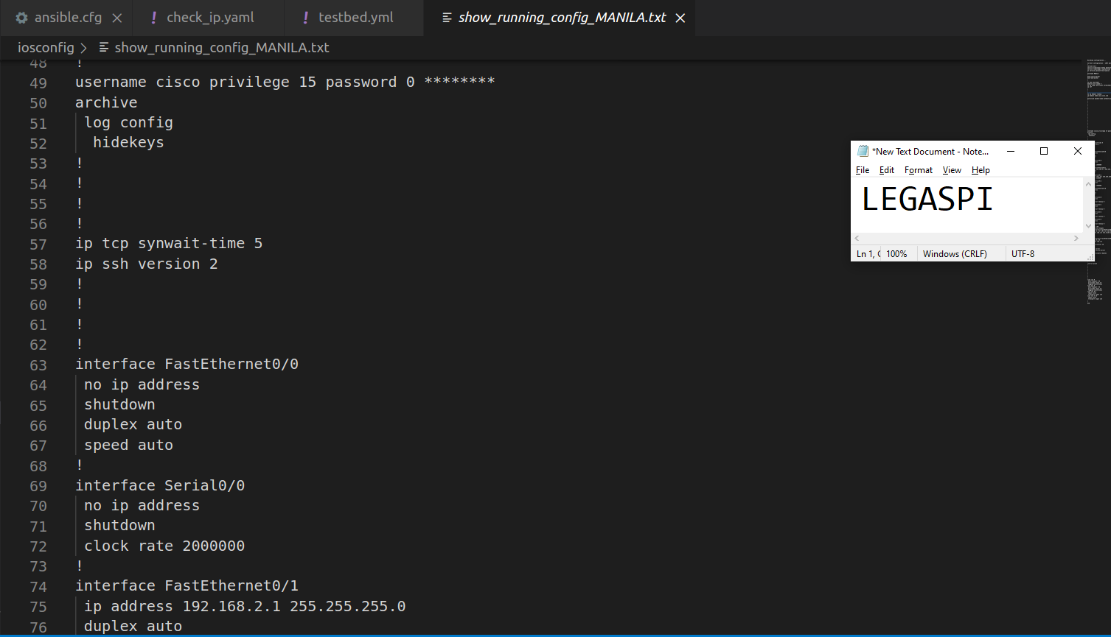

**Show Running Config MANILA**

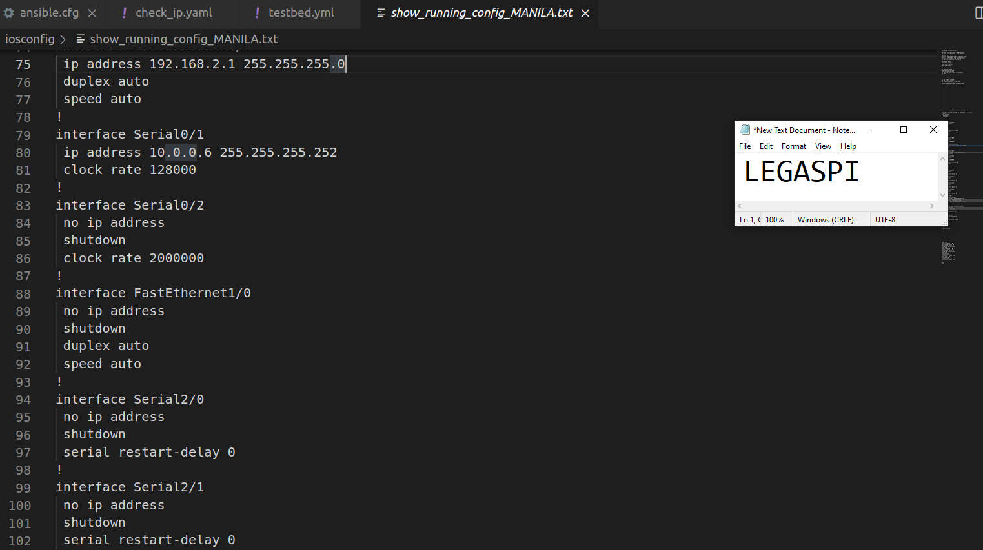

**Show Running Config MANILA**

**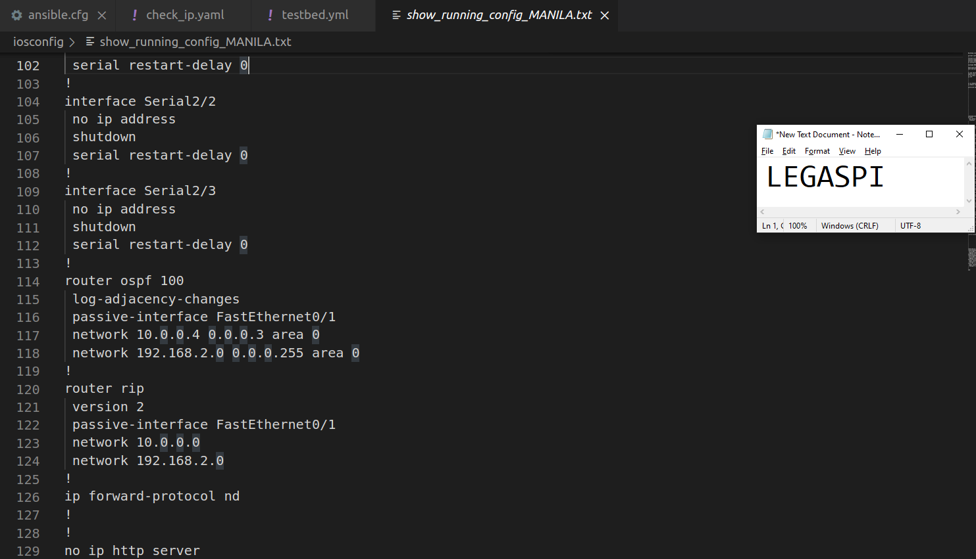  
Show Running Config MANILA**

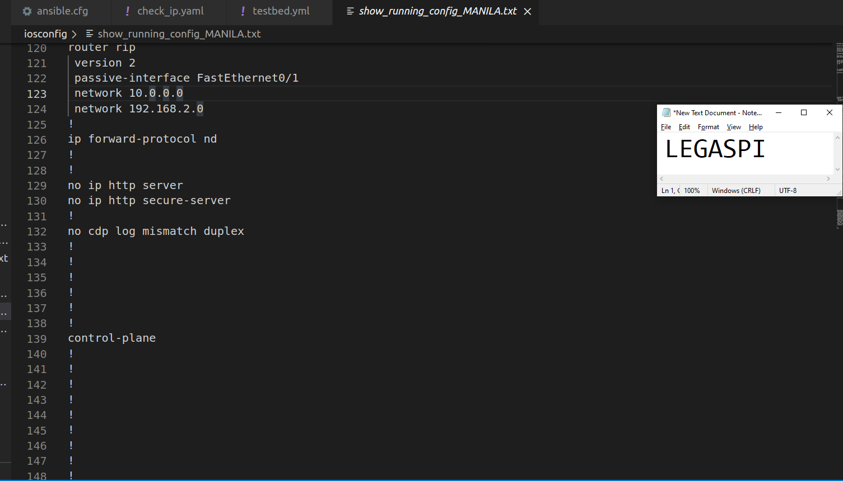 **Show Running Config MANILA**

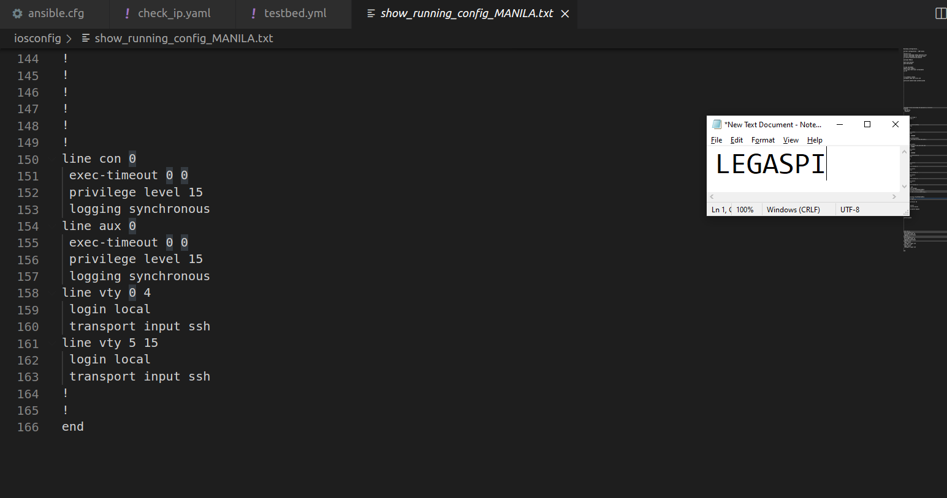

**Show Running Config MANILA**

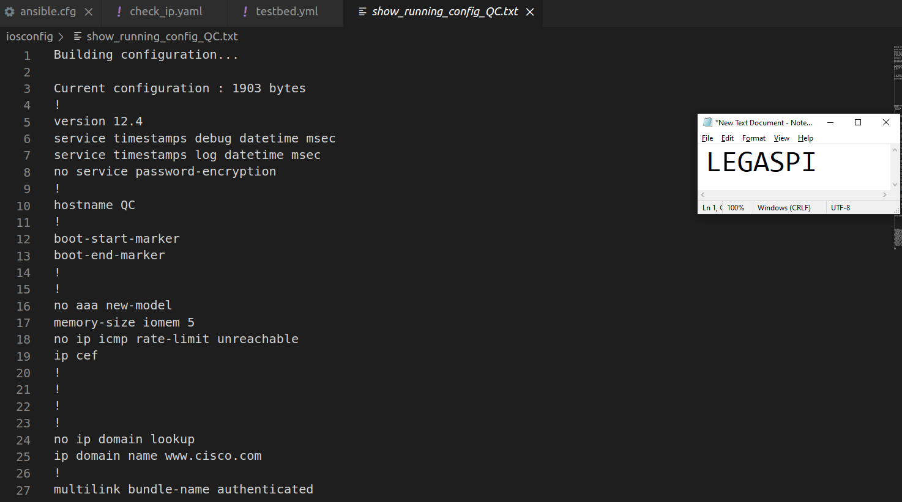

**Show Running Config QC**

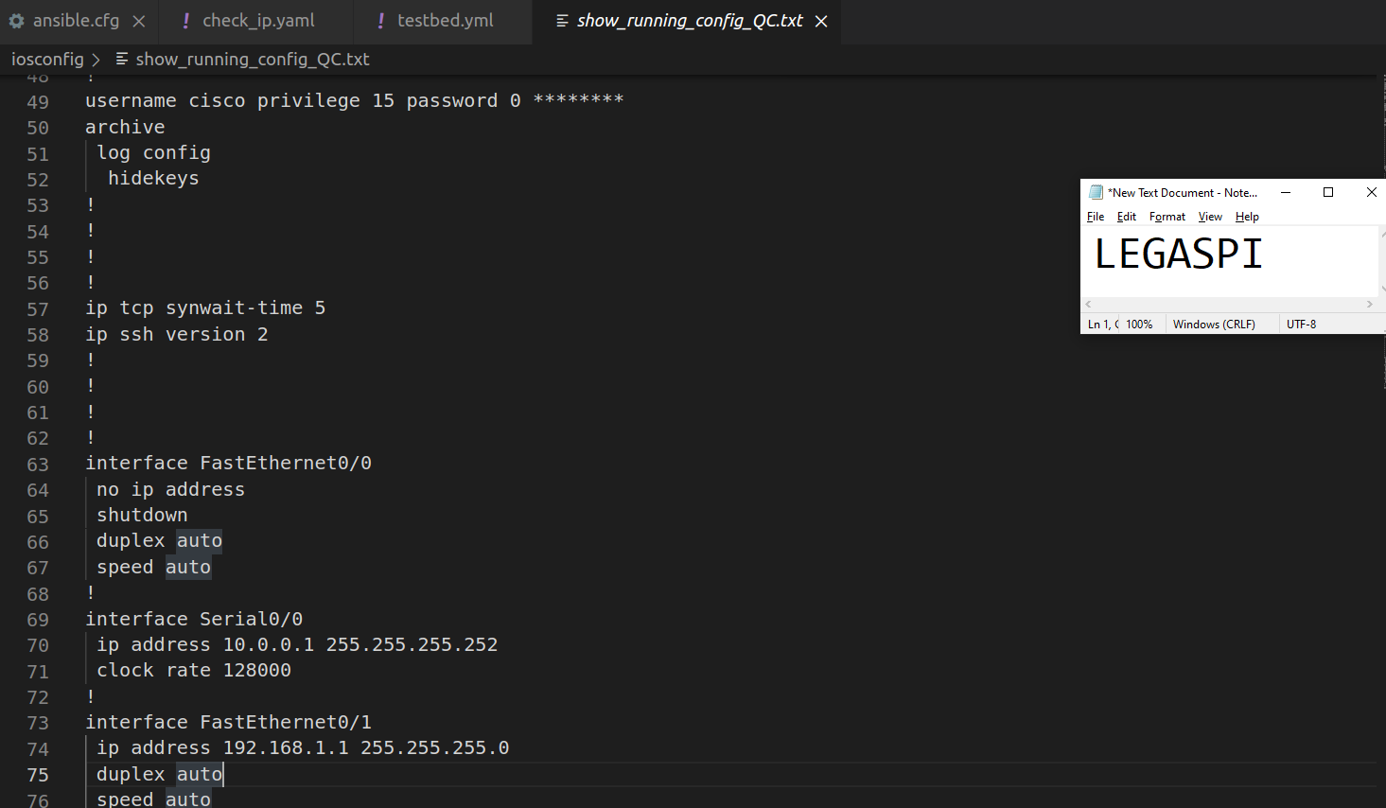

**Show Running Config QC**

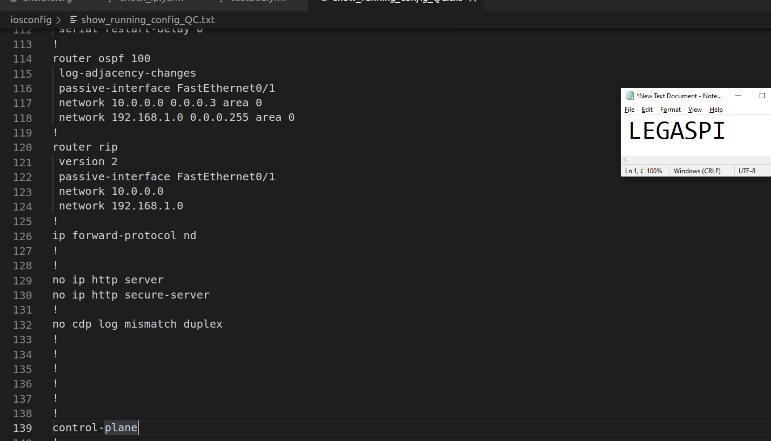

**Show Running Config QC**

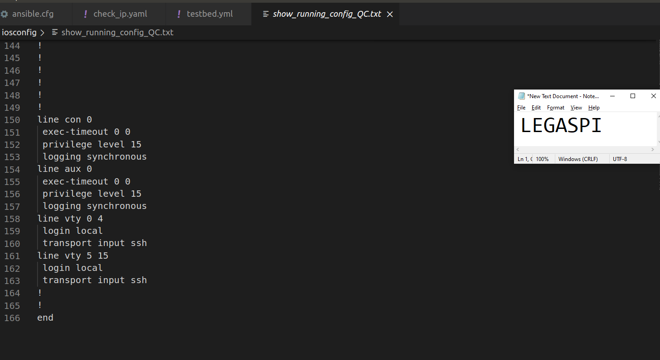

**Show Running Config QC**

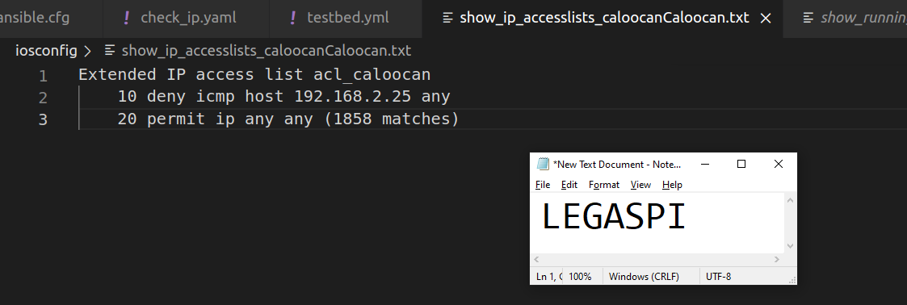

**SHOW IP ACCESS-LISTS Caloocan Router**

**PYATS GENIE:**

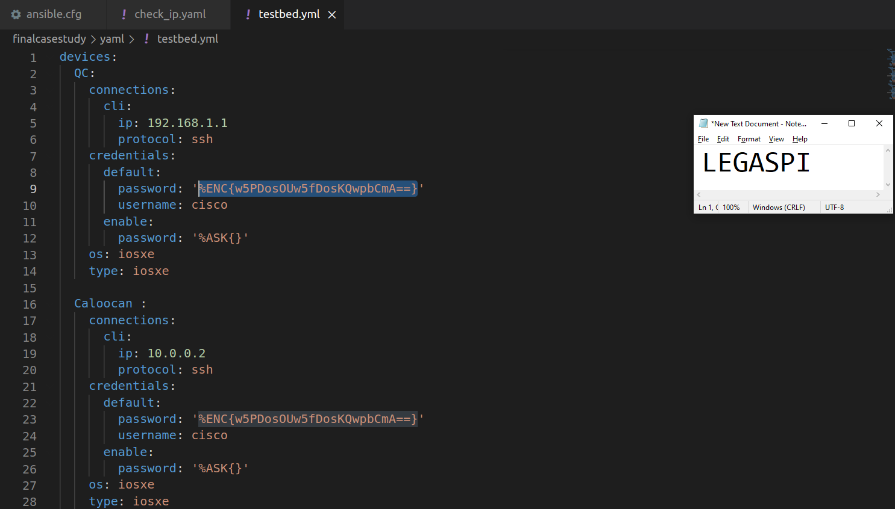

**Testbed Yaml**

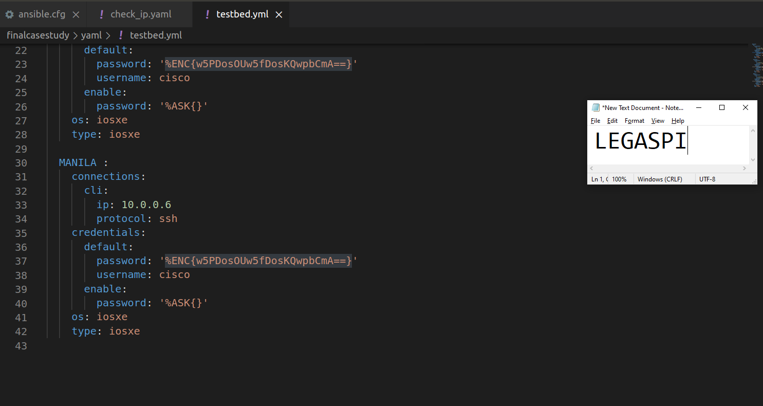

**Testbed Yaml**

**PYATS RESULT:**

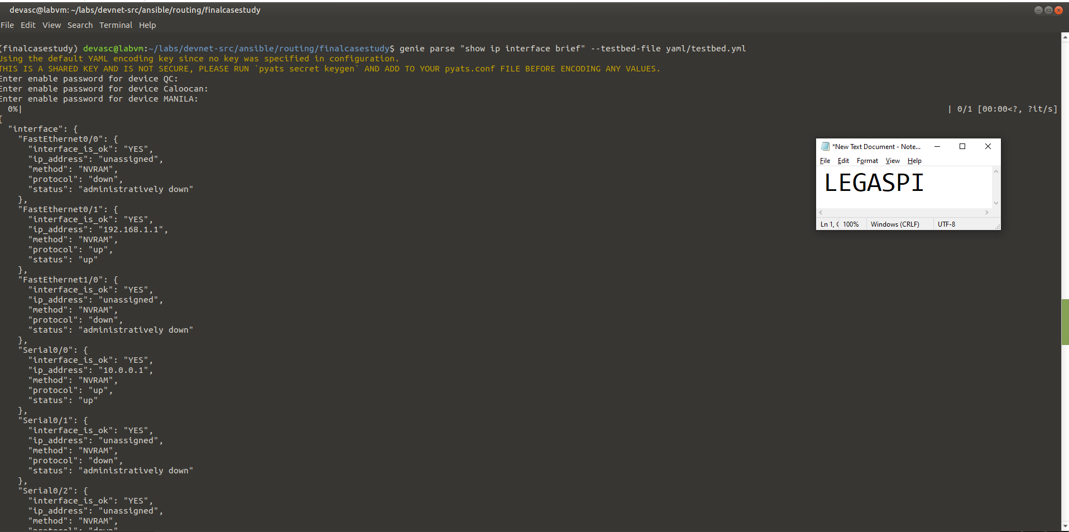

**Show IP interface brief**

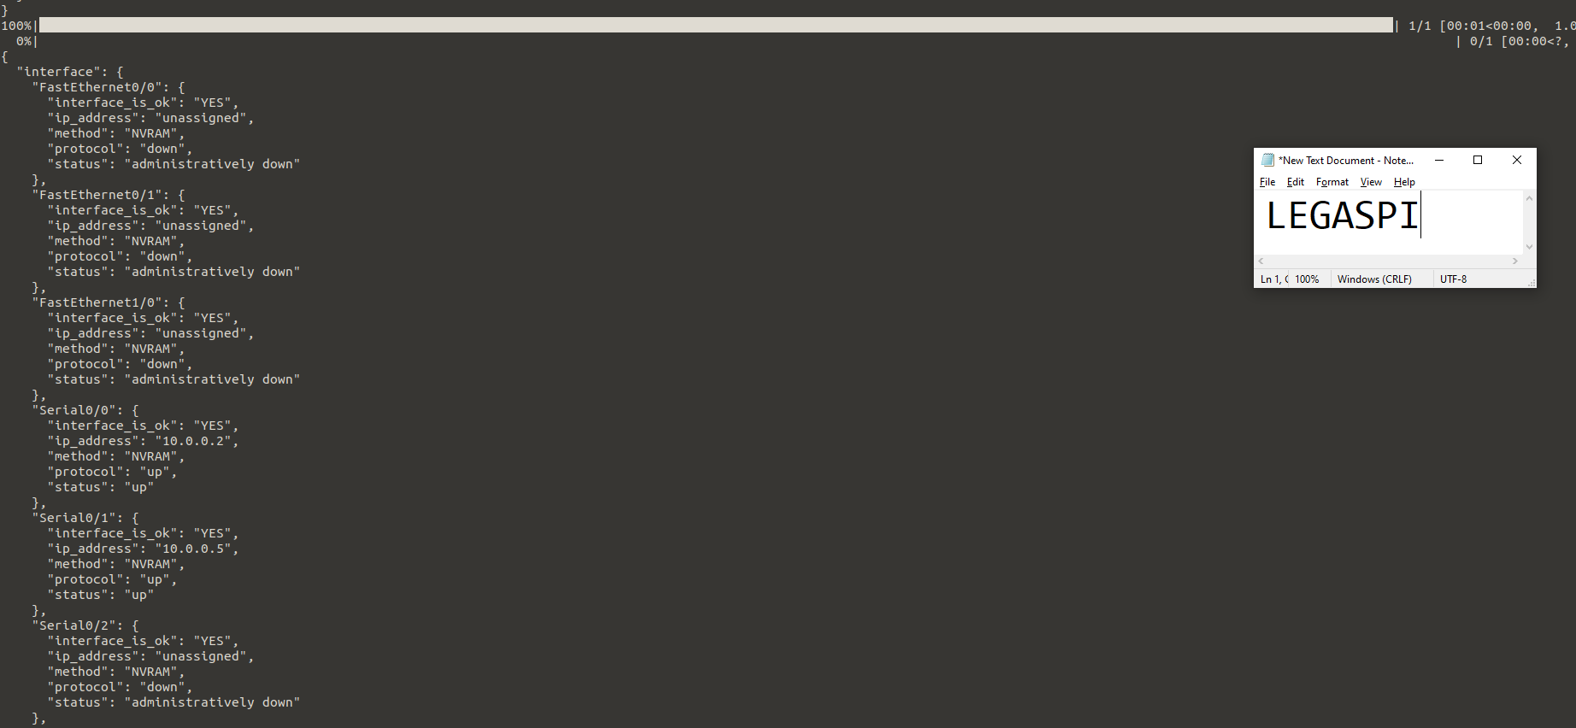

**Show IP interface brief**

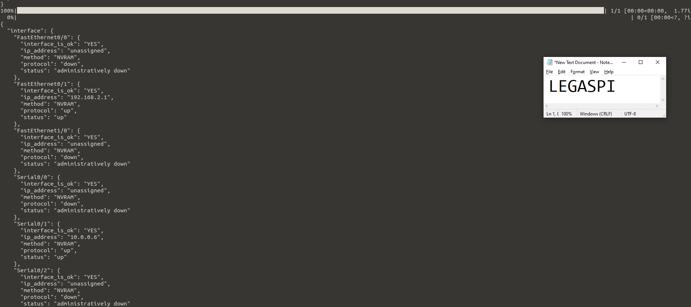

**Show IP interface brief**

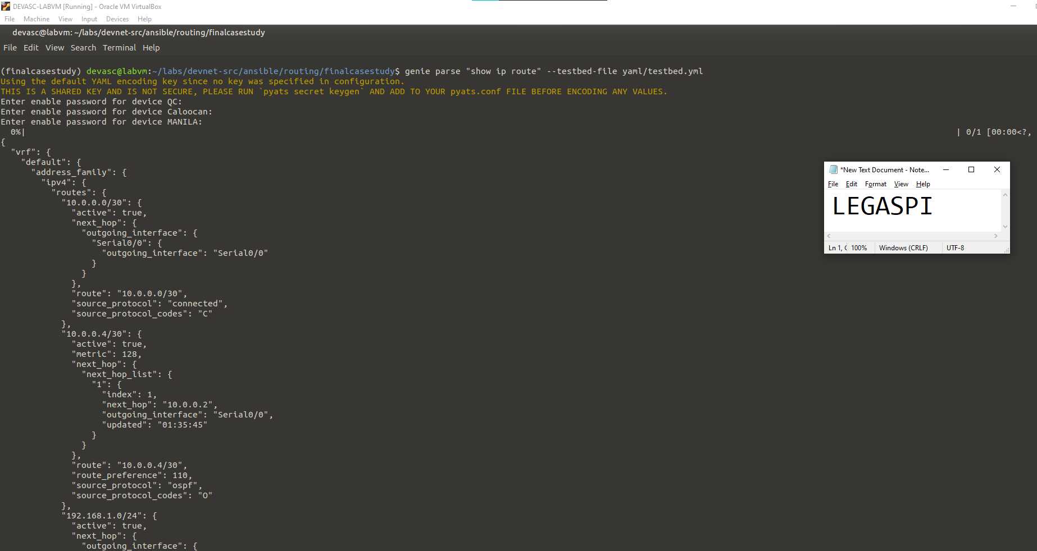

**Show IP Route**

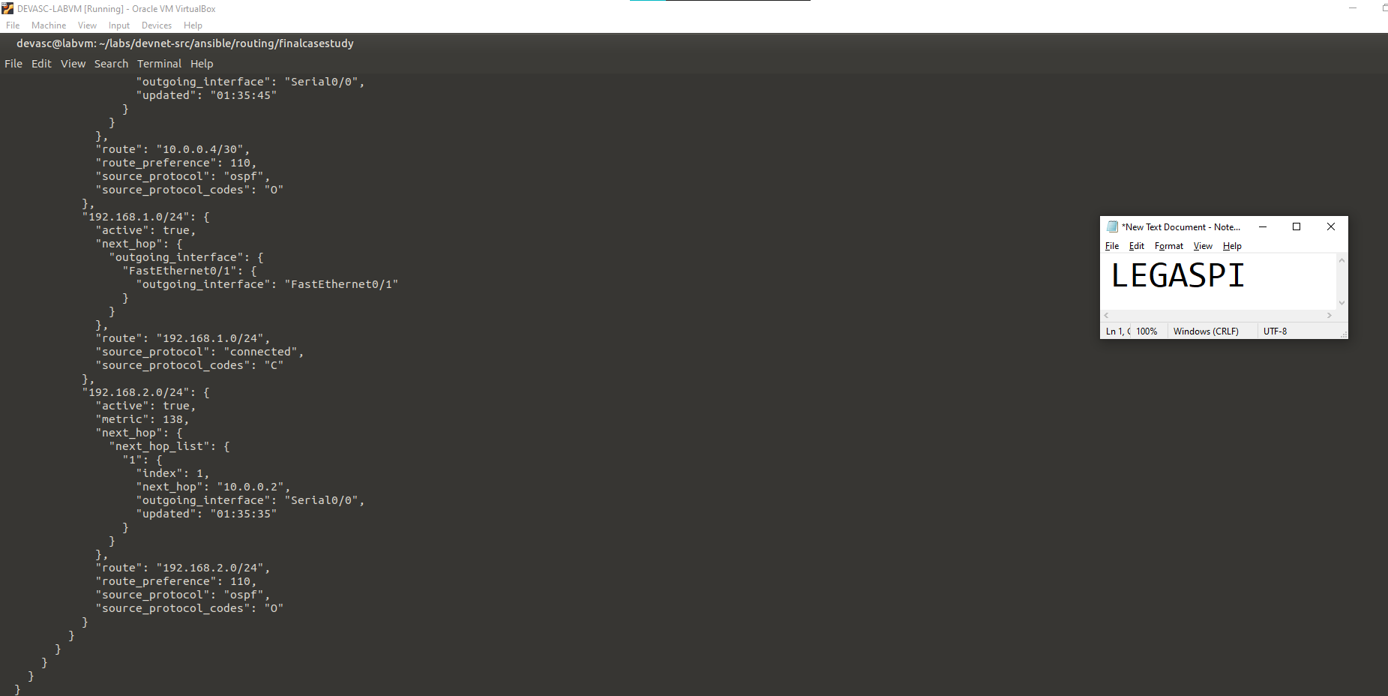

**Show IP Route**

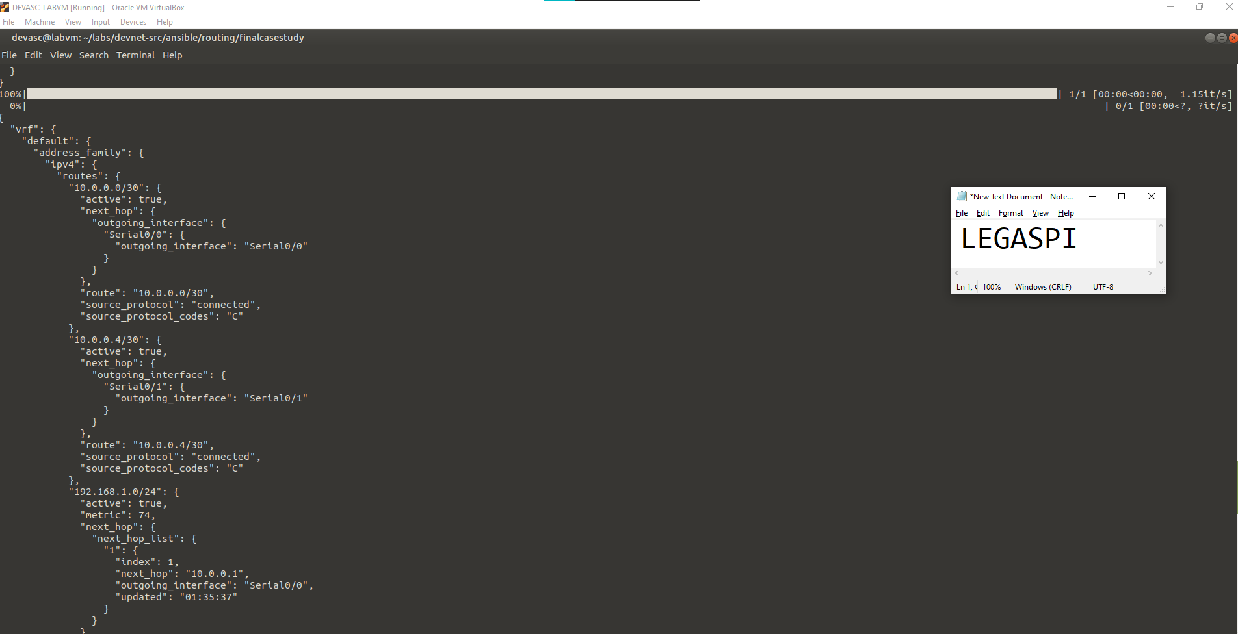

**Show IP Route**

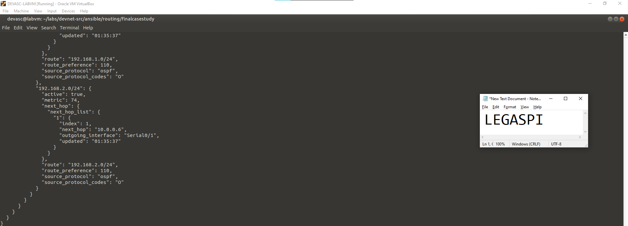

**Show IP Route**

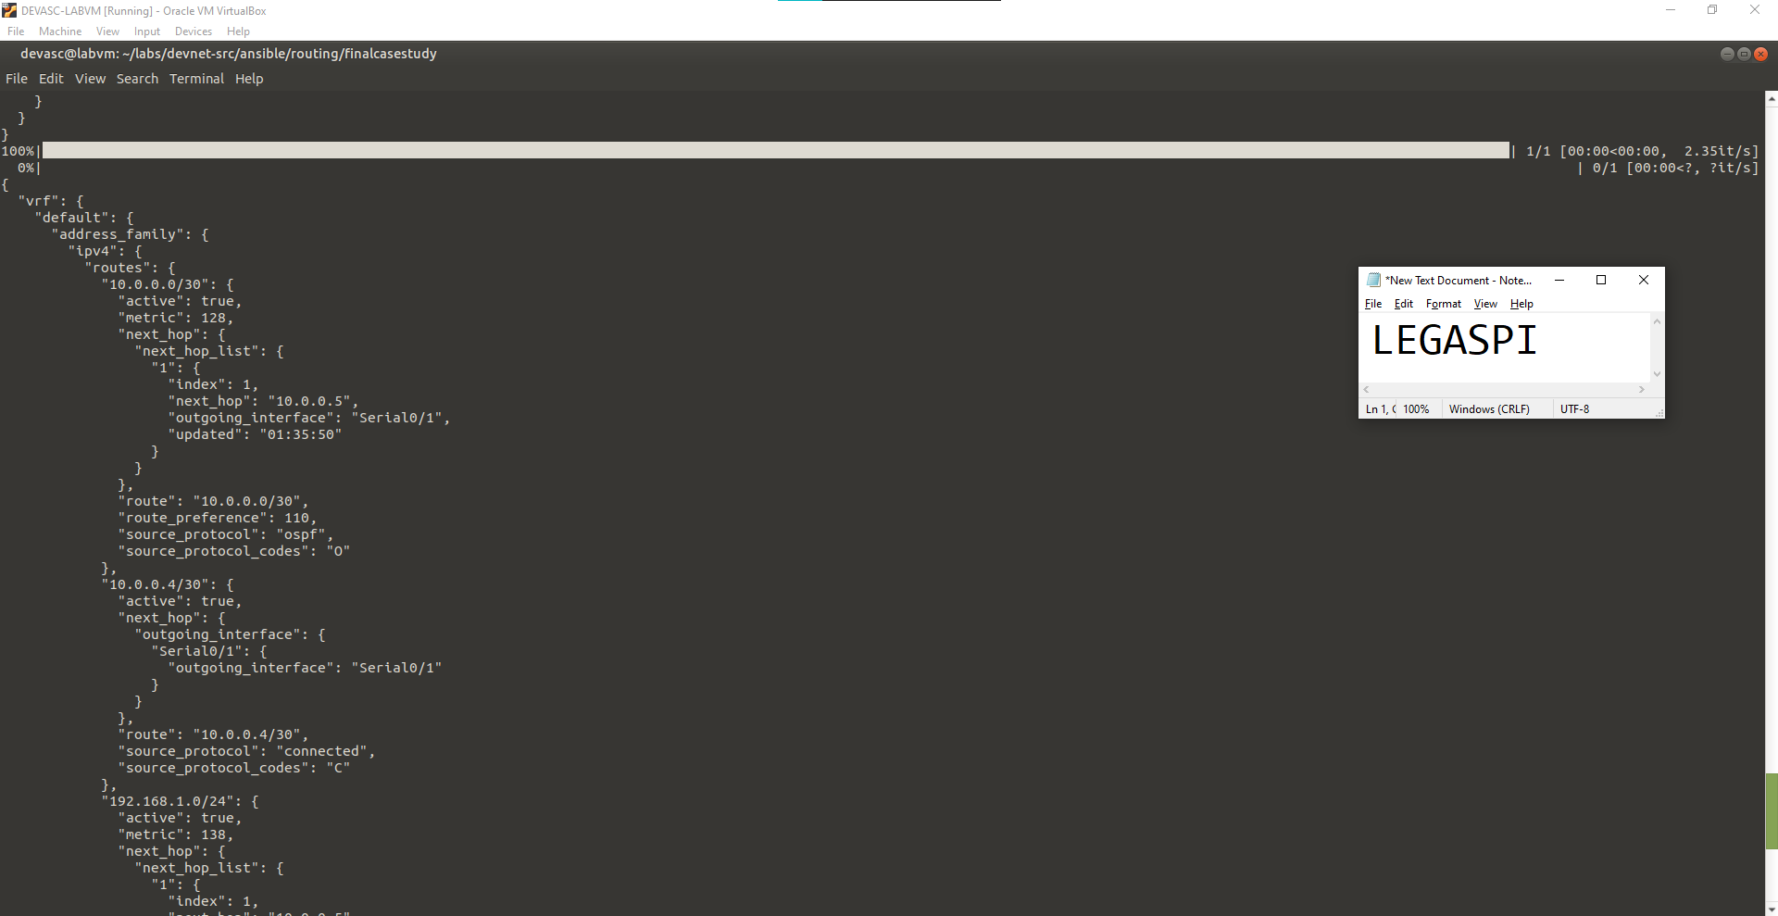

**Show IP Route**

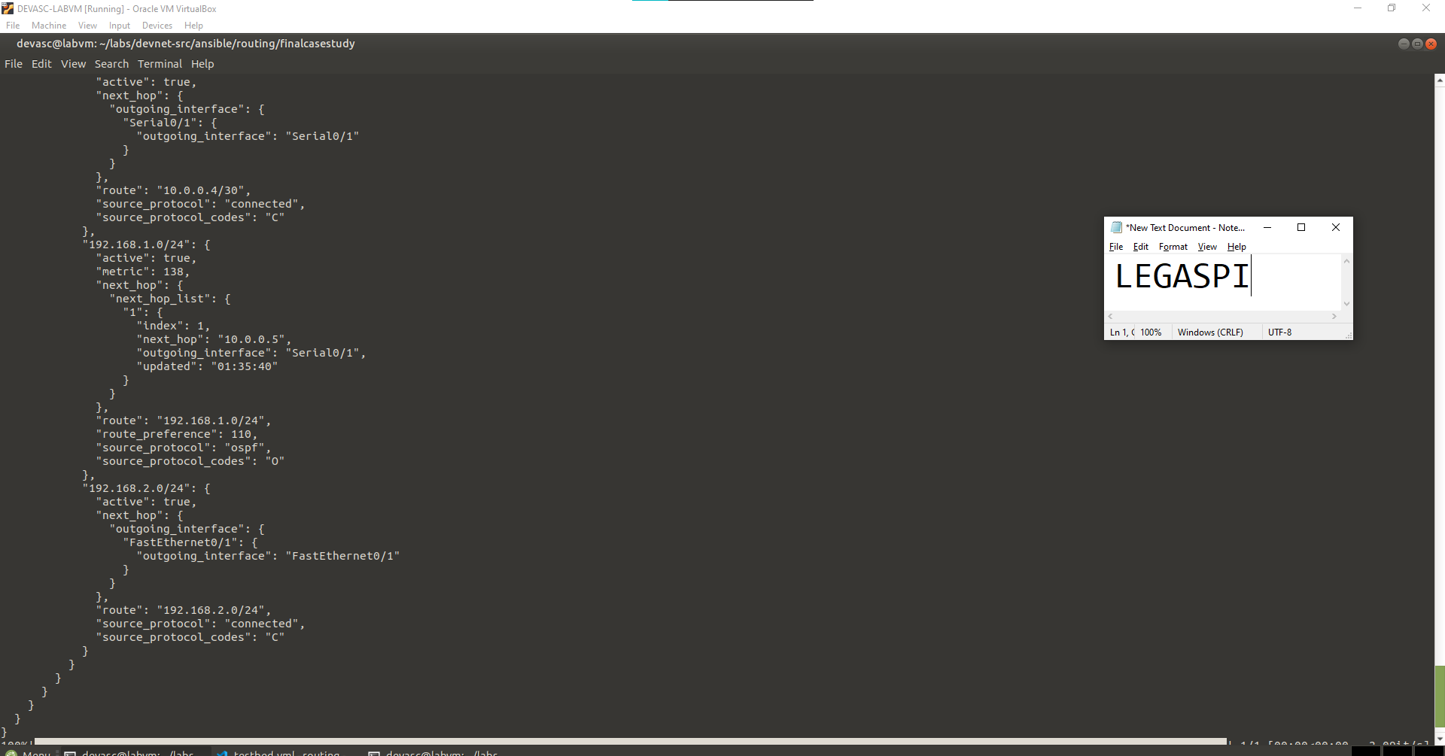

**Show IP Route**

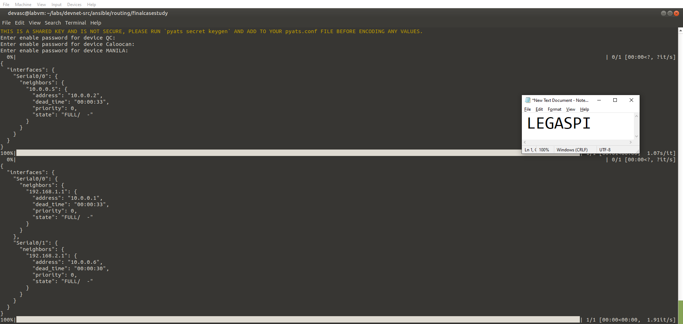

**SHOW IP OSPF NEIGHBOR**

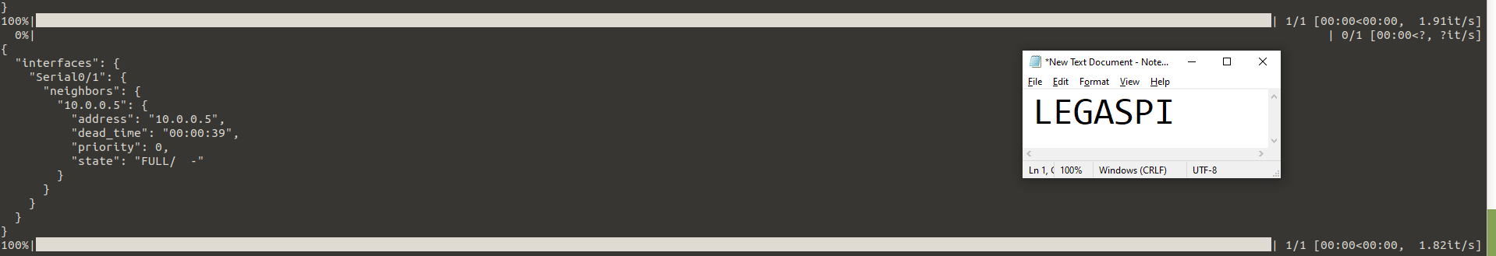

**SHOW IP OSPF NEIGHBOR**

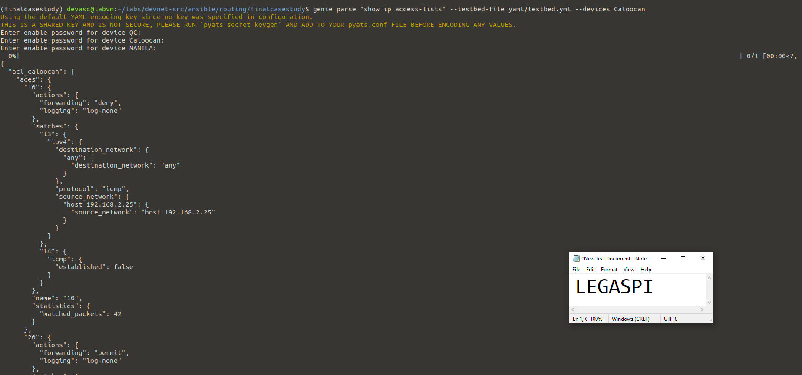

**Show IP acces-lists**

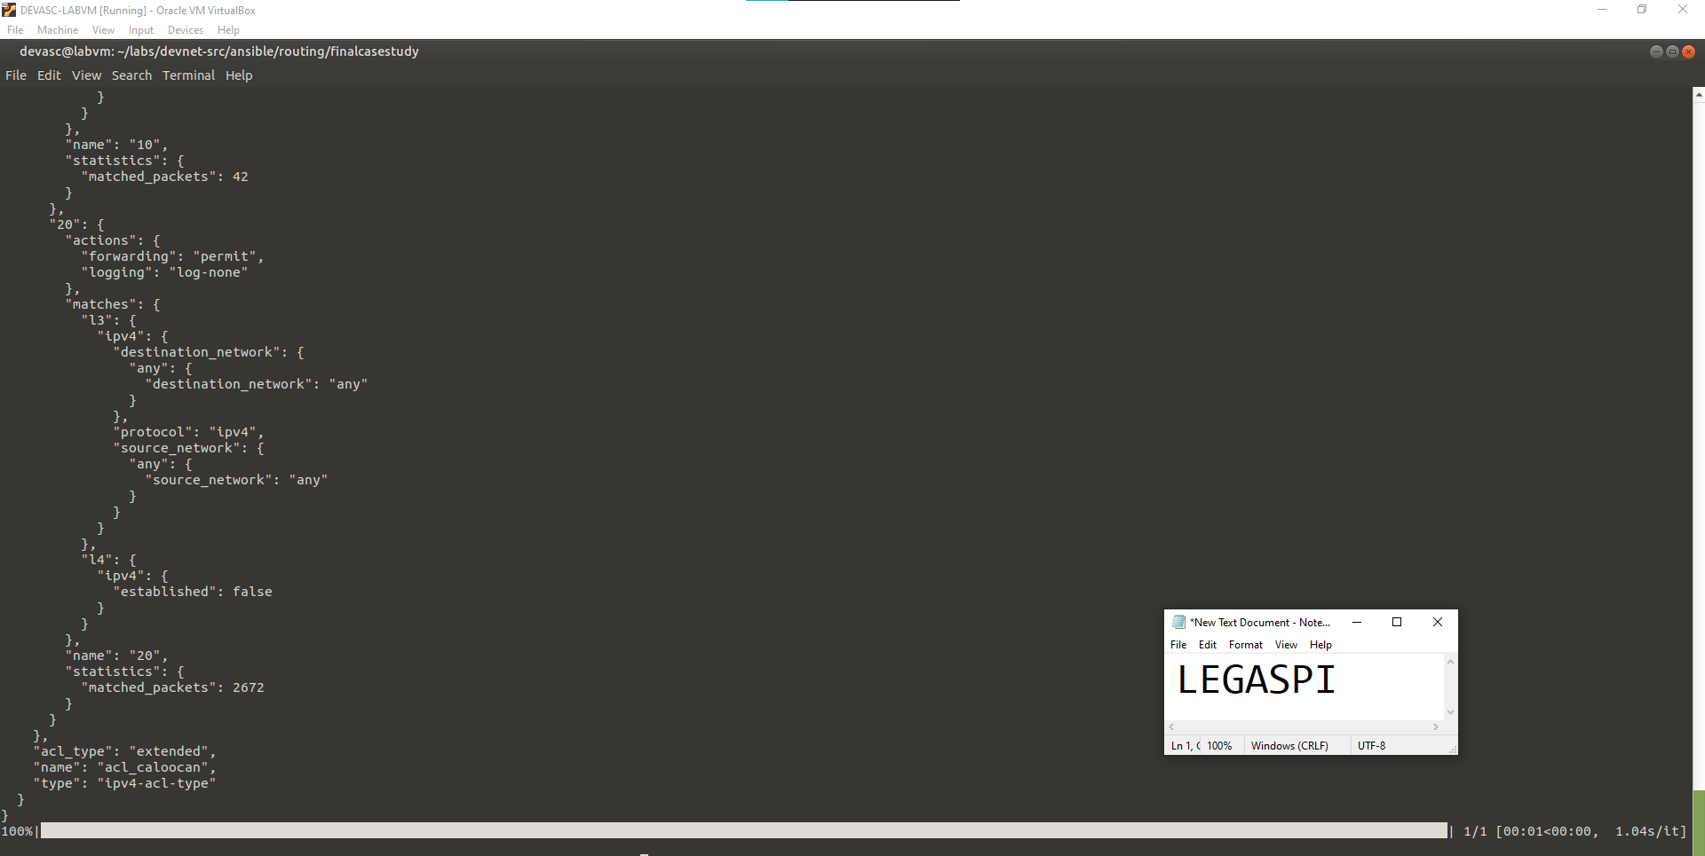

**Show IP acces-lists**

**PING FROM DEVASC LABVM 1 to other Networks**

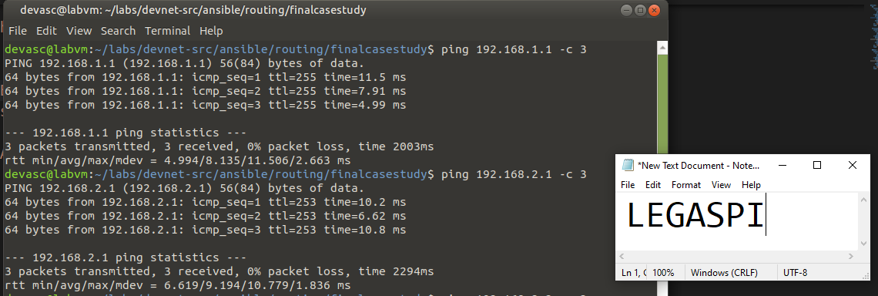

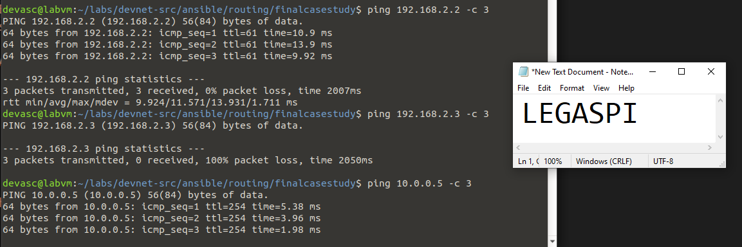

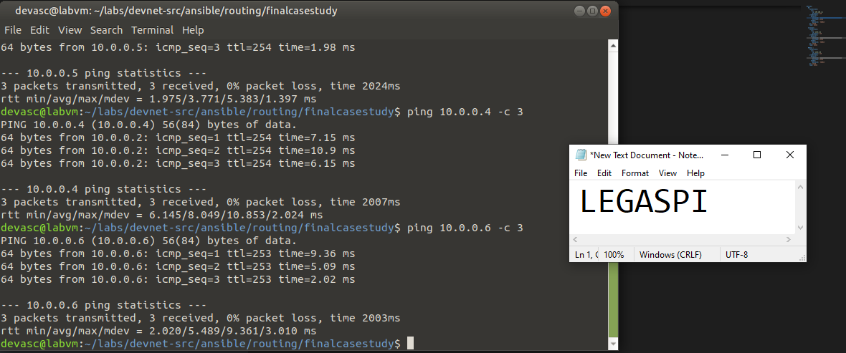

**PING FROM DEVASC LABVM 2 to other Networks**

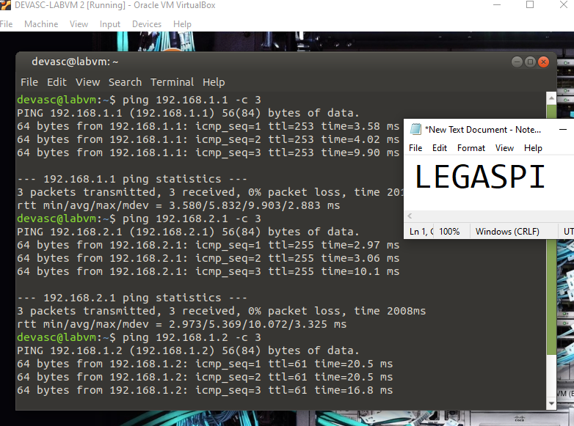

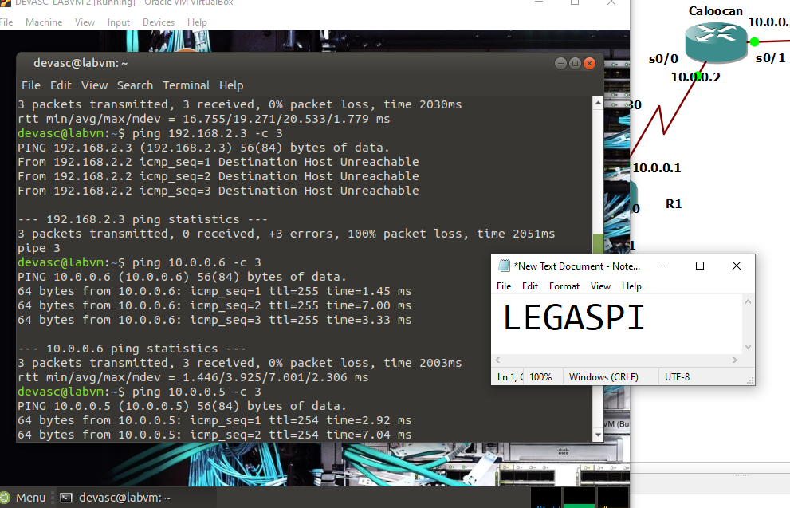

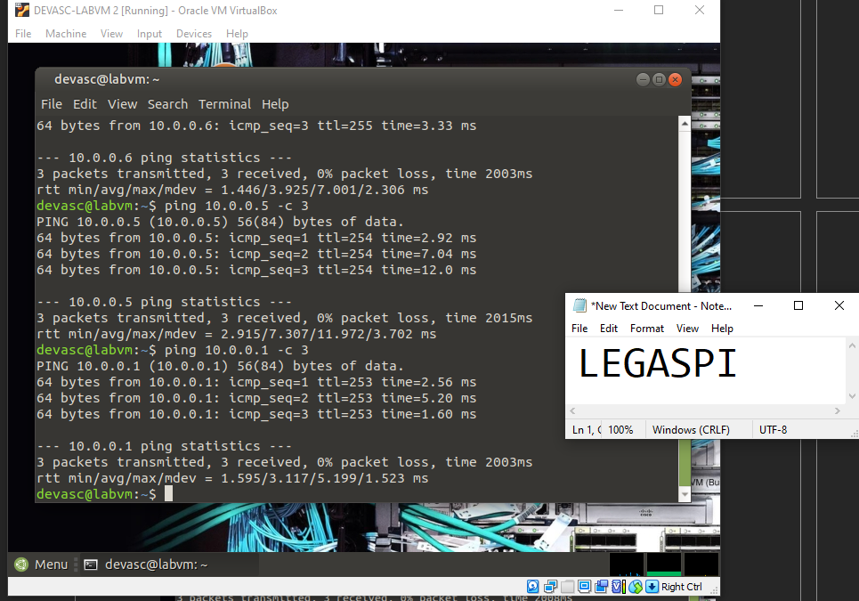

**PING FROM DEVASC LABVM 3 to other Networks**

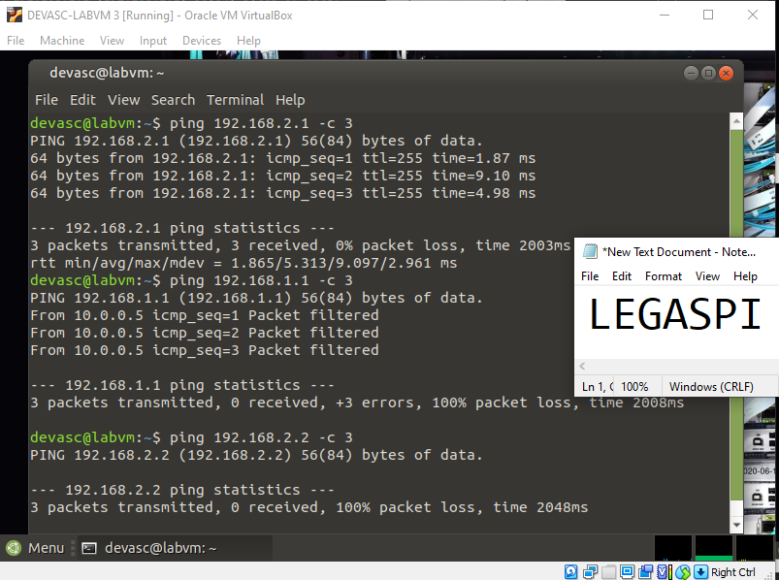

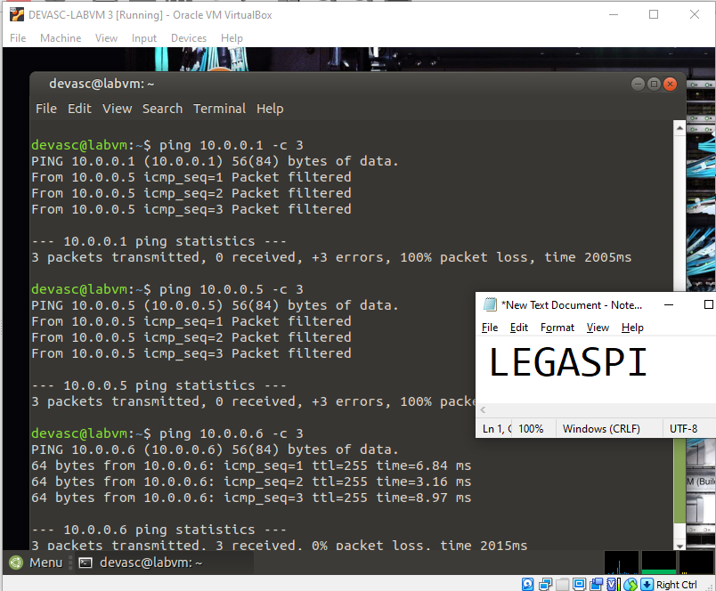

**GOOGLE DRIVE LINK:** [**https://bit.ly/LEGASPICASESTUDY**](https://bit.ly/LEGASPICASESTUDY)

***“I affirm that I have not given or received any unauthorized help on this assignment, and that this work is my own.”***